NAT Gateway

🌐 What is a NAT Gateway?
# Source: Chatgpt (GPT‑5 Mini) at [12/18/2025]
A NAT Gateway (Network Address Translation Gateway) is a network device or cloud service that enables private (internal) devices to access the internet while keeping their private IP addresses hidden. It translates internal IP addresses to a public IP address for outbound traffic — but blocks inbound connections unless explicitly allowed.
✅ In simple terms: A NAT Gateway lets devices in a private network go out to the internet, but prevents the internet from coming in uninvited.

🔧 What It Does
# Source: Chatgpt (GPT‑5 Mini) at [12/18/2025]
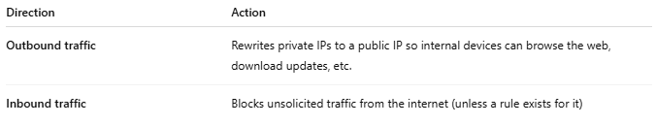

Direction | Action
Outbound traffic | Rewrites private IPs to a public IP so internal devices can browse the web, download updates, etc.
Inbound traffic | Blocks unsolicited traffic from the internet (unless a rule exists for it)

🏠 Simple Home Example
# Source: Chatgpt (GPT‑5 Mini) at [12/18/2025]
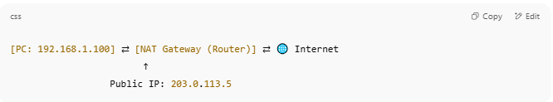

[PC: 192.168.1.100] ⇄ [NAT Gateway (Router)] ⇄ 🌐 Internet
↑
Public IP: 203.0.113.5

- Your PC sends a request to google.com → NAT Gateway changes the source IP to 203.0.113.5
- Google replies → NAT Gateway translates it back to 192.168.1.100

☁️ Example in AWS (Cloud)
# Source: Chatgpt (GPT‑5 Mini) at [12/18/2025]
In AWS, a NAT Gateway allows:
- Instances in private subnets to access the internet (for software updates, etc.)
- Without assigning them public IPs
- Inbound internet connections are not allowed unless initiated by the instance

🧠 NAT Gateway vs Internet Gateway
# Source: Chatgpt (GPT‑5 Mini) at [12/18/2025]
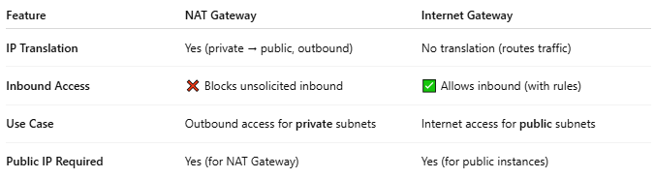

Feature | NAT Gateway | Internet Gateway
IP Translation | Yes (private → public, outbound) | No translation (routes traffic)
Inbound Access | ❌ Blocks unsolicited inbound | ✅ Allows inbound (with rules)
Use Case | Outbound access for private subnets | Internet access for public subnets
Public IP Required | Yes (for NAT Gateway) | Yes (for public instances)

✅ Advantages
# Source: Chatgpt (GPT‑5 Mini) at [12/18/2025]
- ✅ Keeps internal devices secure and private
- ✅ Allows outbound internet access without public IPs
- ✅ Simplifies cloud network design (e.g., AWS, Azure)
- ✅ Scales well (especially in managed cloud NAT services)

❌ Disadvantages
# Source: Chatgpt (GPT‑5 Mini) at [12/18/2025]
- ❌ Cannot receive unsolicited inbound connections
- ❌ Requires public IP or Elastic IP (in cloud)
- ❌ May incur cost in cloud services (e.g., AWS NAT Gateway is billed hourly + per GB)

📌 Summary
# Source: Chatgpt (GPT‑5 Mini) at [12/18/2025]
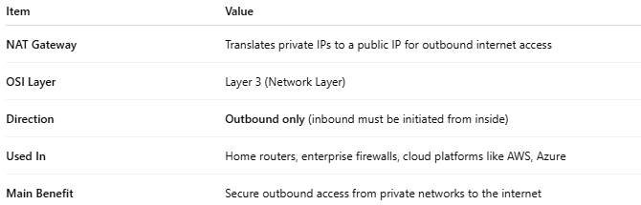

Item | Value
NAT Gateway | Translates private IPs to a public IP for outbound internet access
OSI Layer | Layer 3 (Network Layer)
Direction | Outbound only (inbound must be initiated from inside)
Used In | Home routers, enterprise firewalls, cloud platforms like AWS, Azure
Main Benefit | Secure outbound access from private networks to the internet

